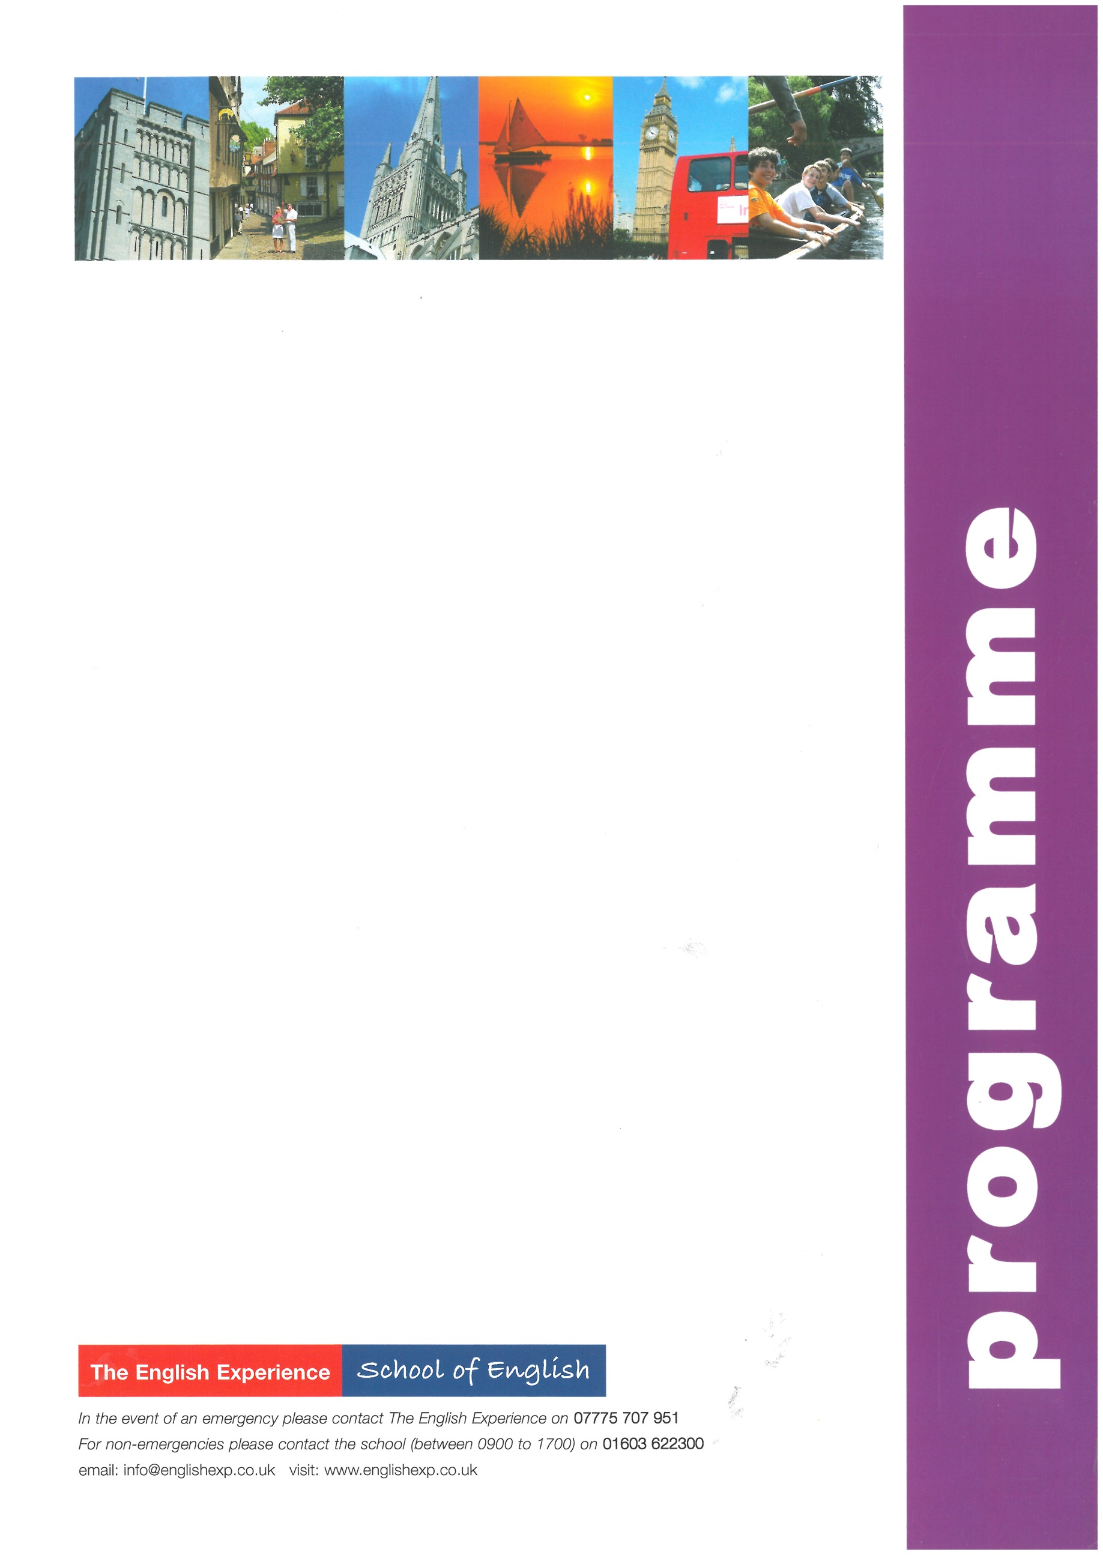
GROUP: Sample 2 week Study Holiday – Hungarian Groups
LEADERS:
CURFEW:
WEEK ONE
Sun | Times to be advised | Students arrive into Asda, Drayton High Road, Norwich and meet Homestay Hosts
Mon | 0900 - 1230  1400 - 1700 | Welcome Talk, Placement Test and English Lessons  Orientation Tour of Norwich - how to find the bank, post office, library, bus stops and meeting points (Meet at The English Experience at 1400)
Tues | 0900 - 1230  1400 - 1700  1900 - 2100 | English Lessons  Five-a-side football in Chapelfield Park (Meet at The Forum Steps at 1400)  10-Pin Bowling at Riverside
Wed | 0900 - 1230  1430 - 1630 | English Lessons  Cinema afternoon at The English Experience (Meet at the English Experience at 1430)
Thurs | 0900 - 1230  1400 - 1700 | English Lessons  Visit to Norwich Castle Museum (Meet at The Forum Steps at 1400)
Fri | 0900 - 1230  1400 - 1700 | English Lessons
Sat | 1000 - 1800 | Full-Day Excursion to the famous University Town of Cambridge to include a walking tour past the main colleges and time to explore this busy town
WEEK TWO
Sun |  | Free day with Homestay Hosts
Mon | 0900 - 1230  1400 - 1700 | English Lessons  A visit to Norwich Cathedral and a Riverside Walk (Meet at The Forum Steps at 1400)
Tues | 0900 - 1230  1400 – 1700  1900 - 2100 | English Lessons  Traditional English Sports in the Park - Rounder’s and Cricket (Meet at The Forum Steps at 1400)  Evening Activity – to be confirmed
Wed | 0900 - 1230  1400 - 1800 | English Lessons  Half-Day Excursion to Great Yarmouth – Norfolk’s premier seaside resort
Thurs | 0900 - 1230  1400 - 1700 | English Lessons  City Search - Work in teams and navigate your way around Norwich - the winning team receives a prize! (Meet at The Forum Steps at 1400)
Fri | 0900 - 1230  1430 - 1630 | English Lessons  London Quiz – test your knowledge before the visit to London (Meet at English Experience at 1430)
Sat | 0720 - 2000 | Full-Day Excursion to London to include a walking tour of the main sights: Houses of Parliament, Whitehall, Trafalgar Square, Westminster Abbey and Buckingham Palace. Lunch in St James’ Park with free time for shopping or to visit a museum or art gallery (Meet at Rouen Road at 0720 – Homestay Hosts to drop off and pick up)
Sun | Times to be advised | Students depart Asda, Drayton High Road, Norwich for return journey home

