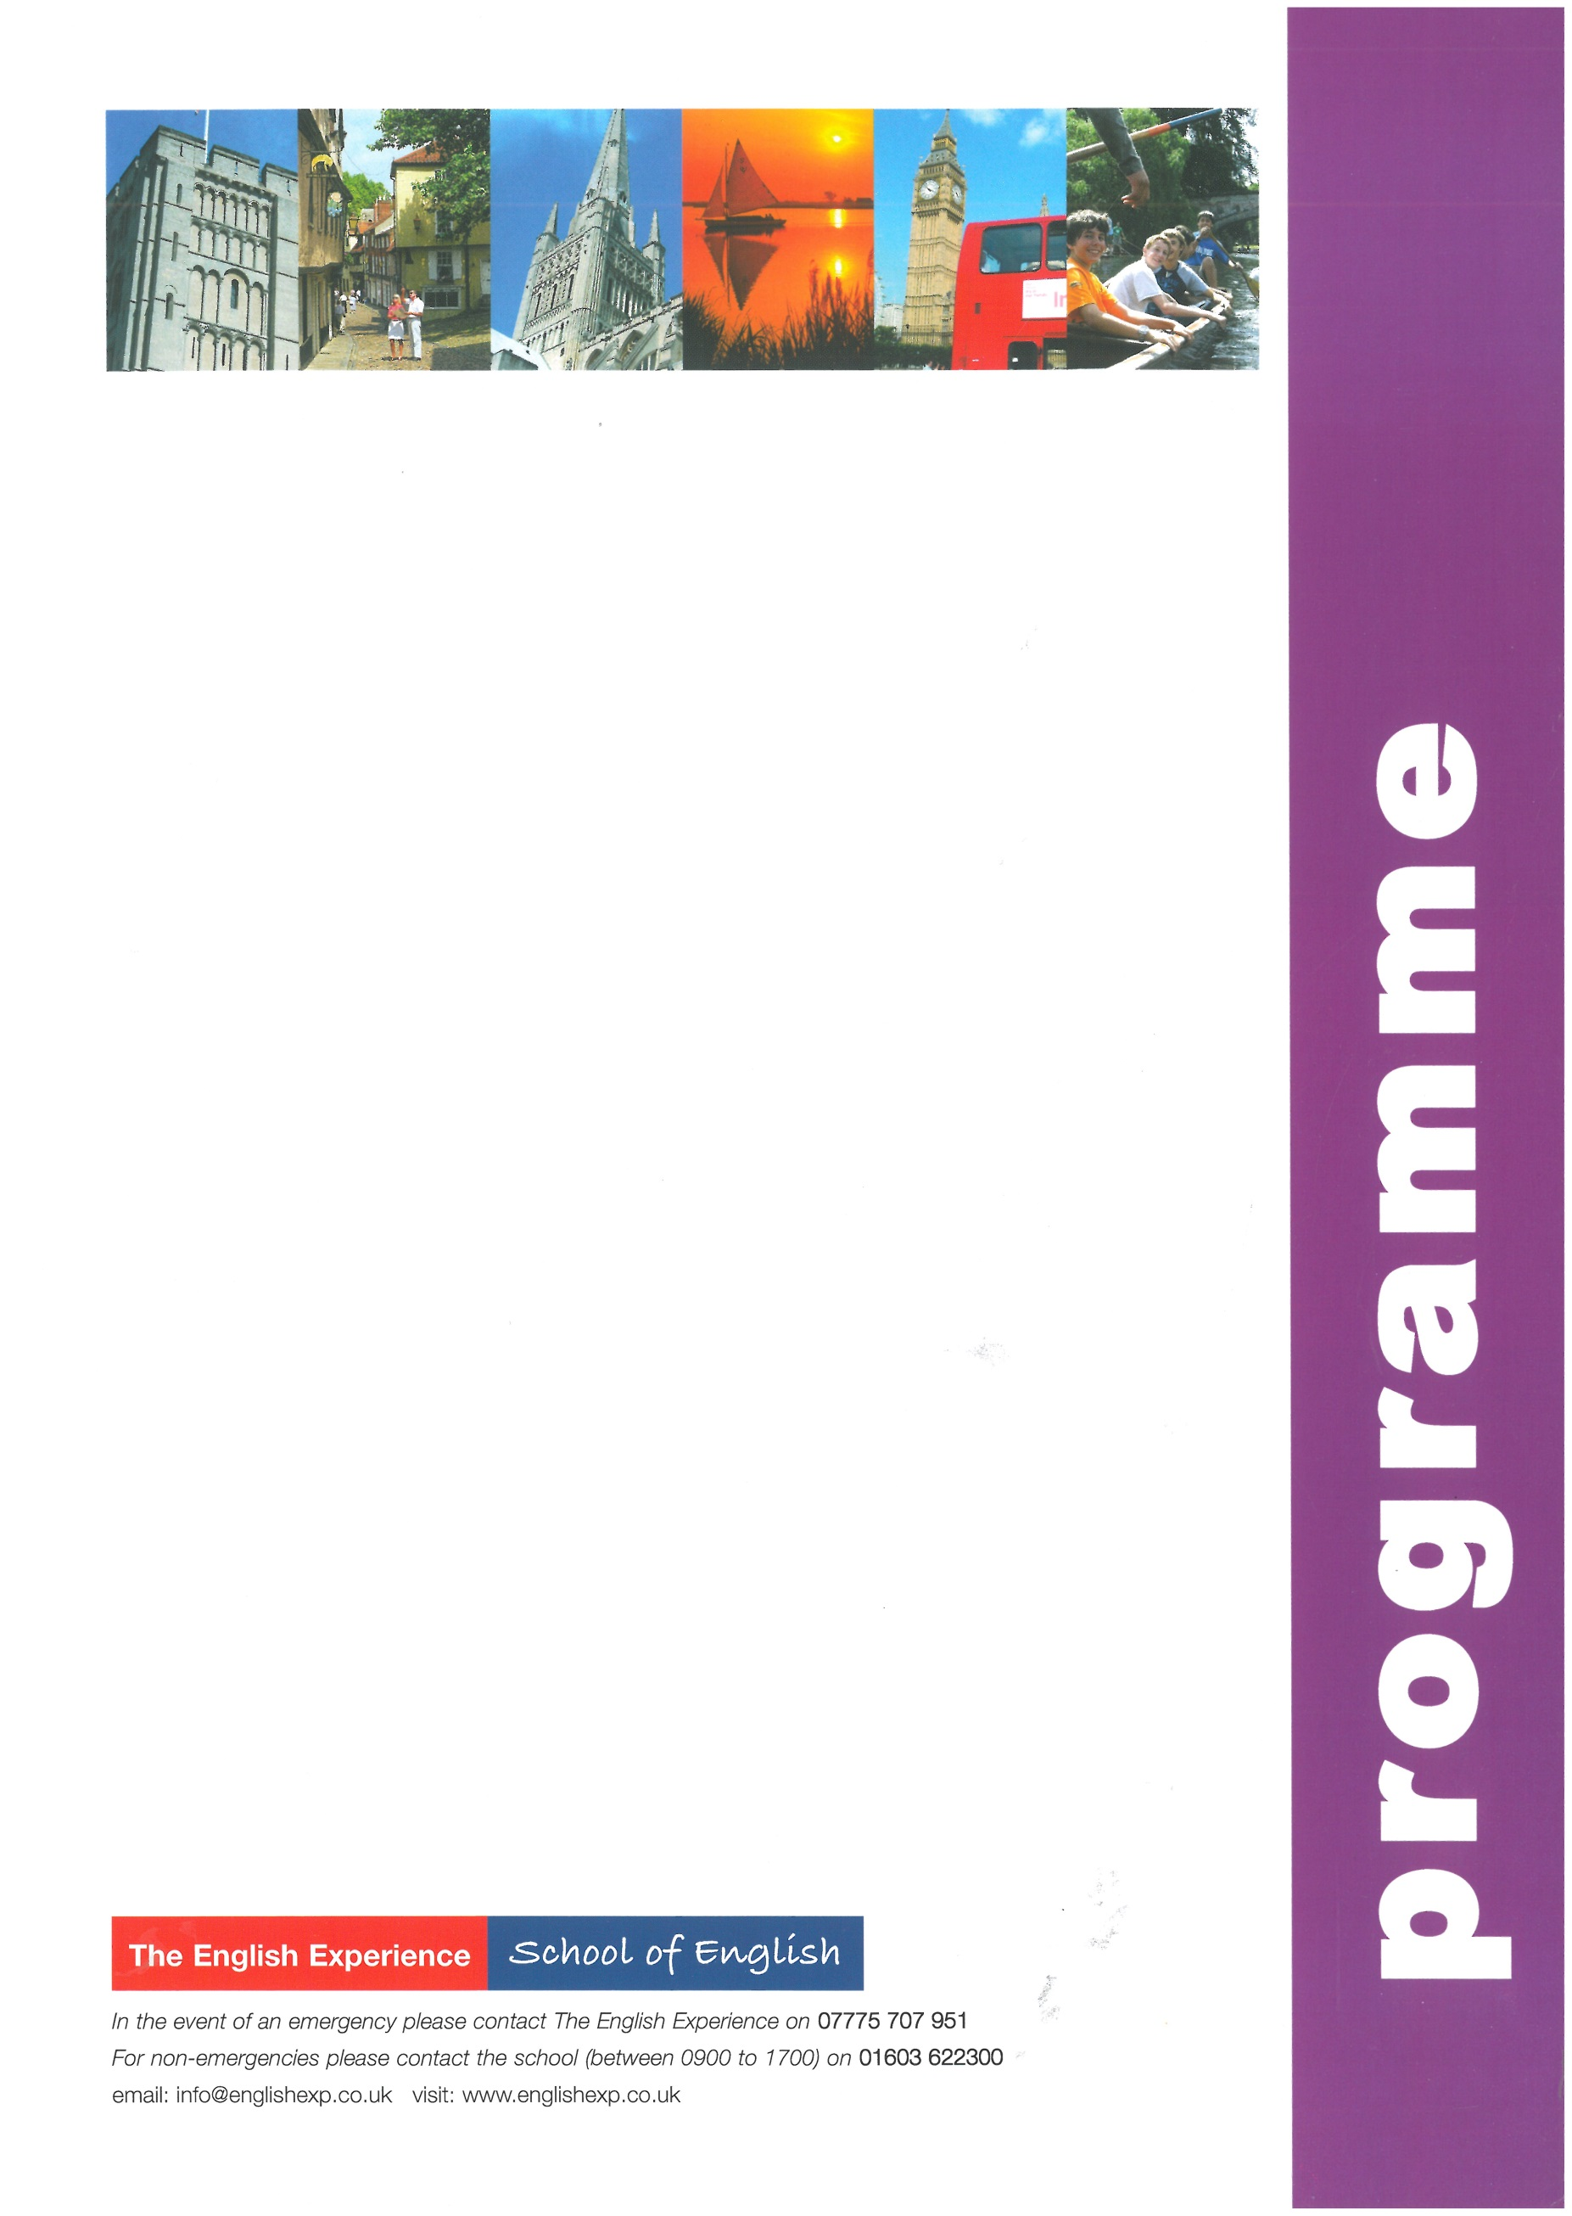
Sample Programme - Summer Study Holiday 1 Week
GROUP:
LEADERS:
CURFEW:
WEEK ONE
Sun | Times to be advised | Students arrive in Norwich and meet Homestay Hosts
Mon | 0900 -1230  1400 -1700 | Welcome Talk and English Lessons  Orientation Tour of Norwich. How to find the bank, post office, shops and meeting points
Tues | 0900 - 1230  1400 - 1700 | English Lessons  A visit to Norwich Cathedral and a Riverside Walk
Wed | 0900 - 1230  1330 - 1800 | English Lessons  Half-Day Excursion to the sea-side town of Cromer - Visit the famous pier and take the chance to see a Cromer Crab
Thurs | 0900 -1230  1400 -1700 | English Lessons  10-Pin Bowling at Hollywood Bowl, Riverside
Fri | 0900 - 1230  1400 - 1700 | English Lessons & Presentation of Certificates  Hip Hop Dance Class at OPEN
Sat | 0900 - 1800 | Full-Day Excursion to Cambridge to include a walking tour past the main college and an optional visit to one of the colleges or Museums
Sun | Times to be advised | Students depart Norwich for return journey home

