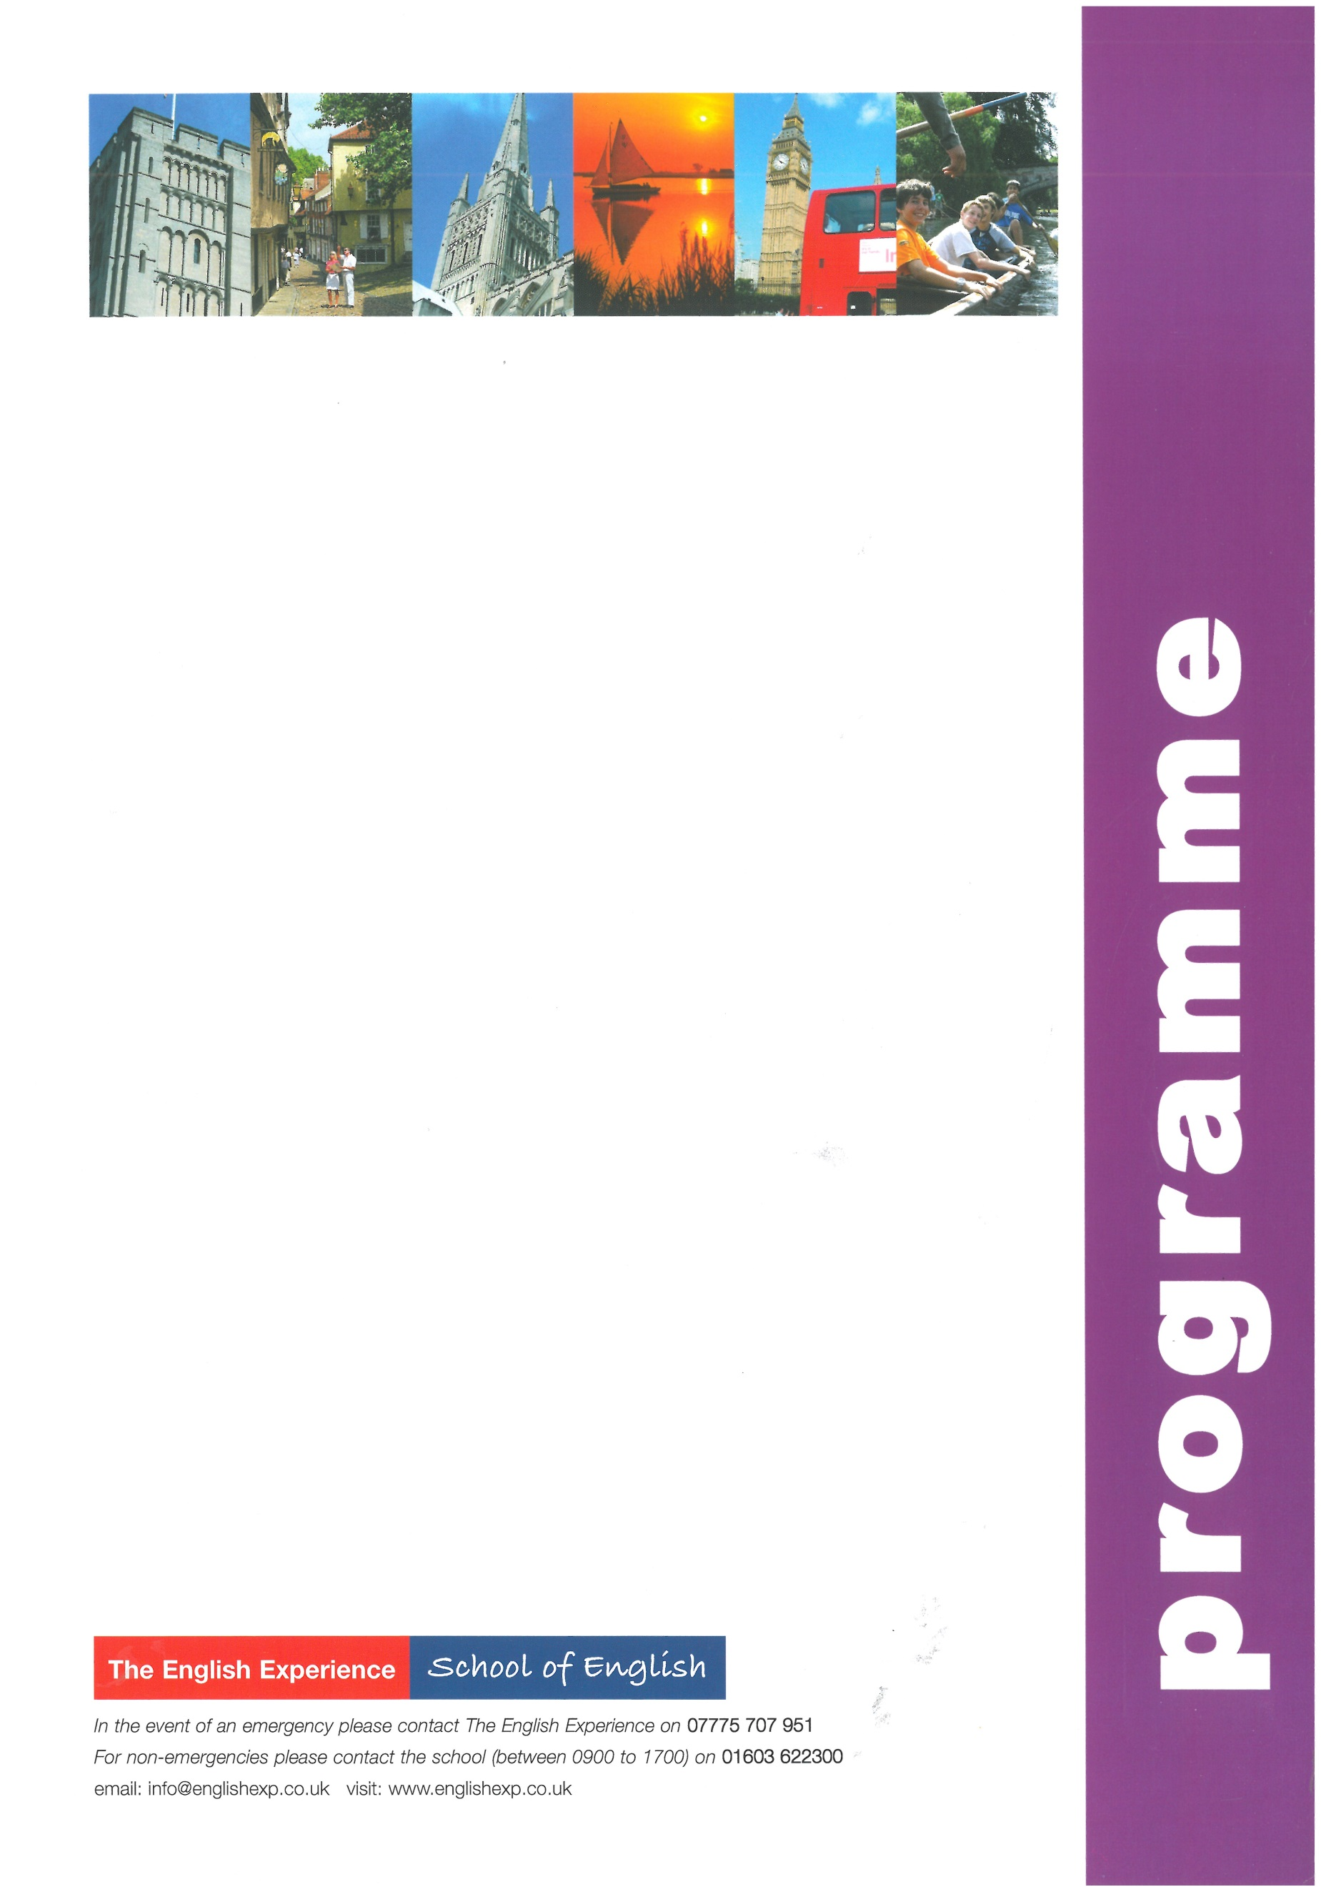
GROUP: Sample Programme - Short Course 13 Nights
LEADERS:
CURFEW:
WEEK ONE
Sun | Times to be advised | Students arrive into Asda, Drayton High Road, Norwich and meet Homestay Hosts
Mon | 0900 - 1230  1400 - 1700 | Welcome Talk, Placement Tests and English Lessons  Orientation of Norwich. How to find the bank, post office, shops and excursion departure points (Meet at The English Experience at 1400)
Tues | 0900 - 1230  1400 – 1700 | English Lessons  Traditional English Sports in the Park - Rounder and Cricket (Meet at the forum steps at 1400)
Weds | 0900 - 1230  1400 - 1700 | English Lessons  10-Pin Bowling at Hollywood Bowl, Riverside (Meet at the forum steps at 1400)
Thurs | 0900 - 1230  1400 - 1700 | English Lessons  A visit to Norwich Castle to discover its past as a former royal palace and prison (Meet at the forum steps at 1400)
Fri | 0900 - 1230  1400 - 1700 | English Lessons  Free afternoon for shopping and exploring more of Norwich
Sat | 0720 - 2000 | Full-Day Excursion to London to include a walking tour past the sights: Houses of Parliament, Whitehall, Trafalgar Square, Westminster Abbey, Buckingham Palace. Lunch in St James’s Park. Free time for shopping or to visit a museum or art gallery. (Meet at the Rouen Road at 0720 – Homestay Hosts to drop off and collect)
WEEK TWO
Sun |  | Free day with Homestay Hosts
Mon | 0900 - 1230  1400 - 1700 | English Lessons  City Search - Navigate your way around Norwich and the winning team receives a prize (Meet at the forum steps at 1400)
Tues | 0900 - 1230  1400 – 1700 | English Lessons  A visit to the Sainsbury Centre for Visual Art at the University of East Anglia (Meet at the forum steps at 1400)
Weds | 0900 - 1230  1400 - 1700 | English Lessons  A trip to the Cinema to see one of the latest releases (Meet at the forum steps at 1400)
Thurs | 0900 - 1230  1400 - 1700 | English Lessons  A visit to Norwich Cathedral and Riverside Walk (Meet at the forum steps at 1400)
Fri | 0900 - 1230  1400 - 1700 | English Lessons and presentation of reports  Free afternoon for shopping and exploring more of Norwich
Sat | Times to be advised | Students depart Asda, Drayton High Road, Norwich for return journey home

