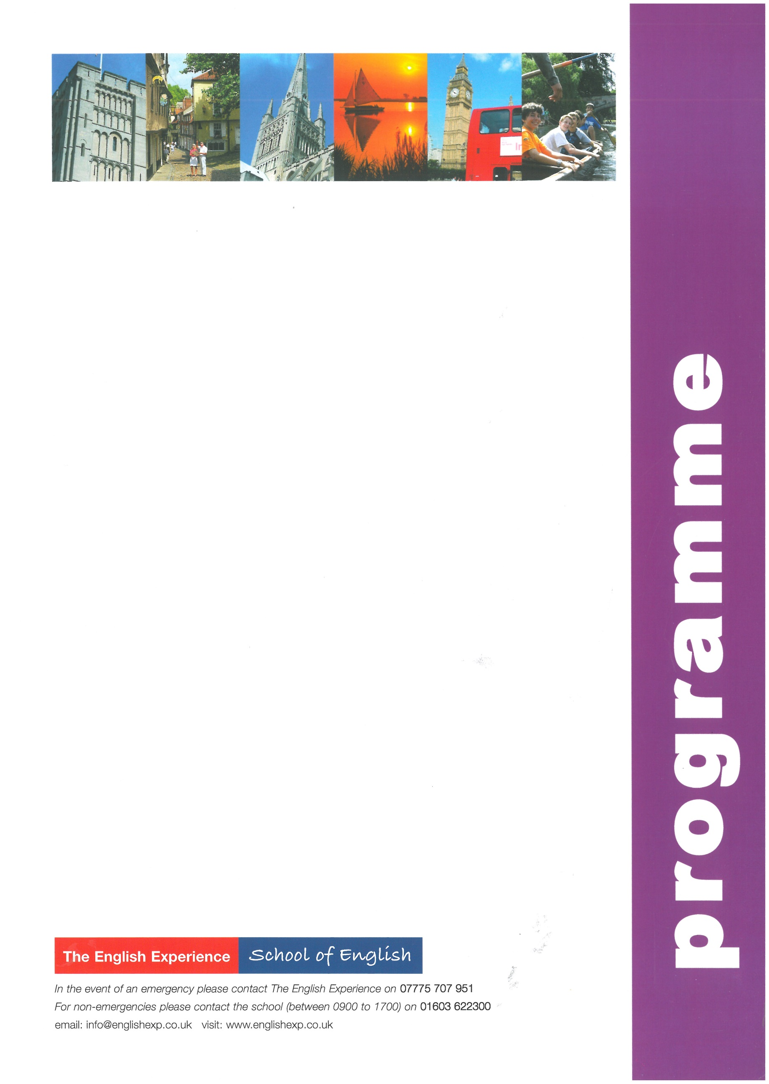
Sample Programme – School Integration 1 Week
GROUP:
LEADERS:
CURFEW:
Sun | Times to be advised | Students arrive into Asda, Drayton High Road, Norwich and meet Homestay Hosts
Mon | 0830  0840 - 1545  1545 - 1700 | Meet English Experience Activity Leader at School Reception  All day lessons such as English and History at High School with English buddies  Orientation Tour of Norwich - how to find the bank, post office, library, bus stops and meeting points
Tues | 0830  0840 – 1545  1545 | Meet English Experience Activity Leader at School Reception  All day lessons such as Geography and Science at High School with English buddies  Free time with Homestay Hosts and evening meal
Weds | 0830  0840 - 1545  1545 | Meet English Experience Activity Leader at School Reception  All day lessons such as English and Sports at High School with English buddies  Free time with Homestay Hosts and evening meal
Thurs | 0830  0840 - 1545  1545 | Meet English Experience Activity Leader at School Reception  All day lessons such as Information Technology and Literature at High School with English buddies  Free time with Homestay Hosts and evening meal
Fri | 0830  0840 - 1545  1545 | Meet English Experience Activity Leader at School Reception  All day lessons such as Cooking and Maths at High School with English buddies  Free time with Homestay Hosts and evening meal
Sat | 0720 - 2000 | Full-Day Excursion to London to include a walking tour past the main sights; Houses of Parliament, Whitehall, Trafalgar Square, Westminster Abbey, Buckingham Palace and Covent Garden with lunch in St James’s Park. Free time to visit an art gallery or museum
Sun | Times to be advised | Students depart Asda, Drayton High Road, Norwich for return journey home

