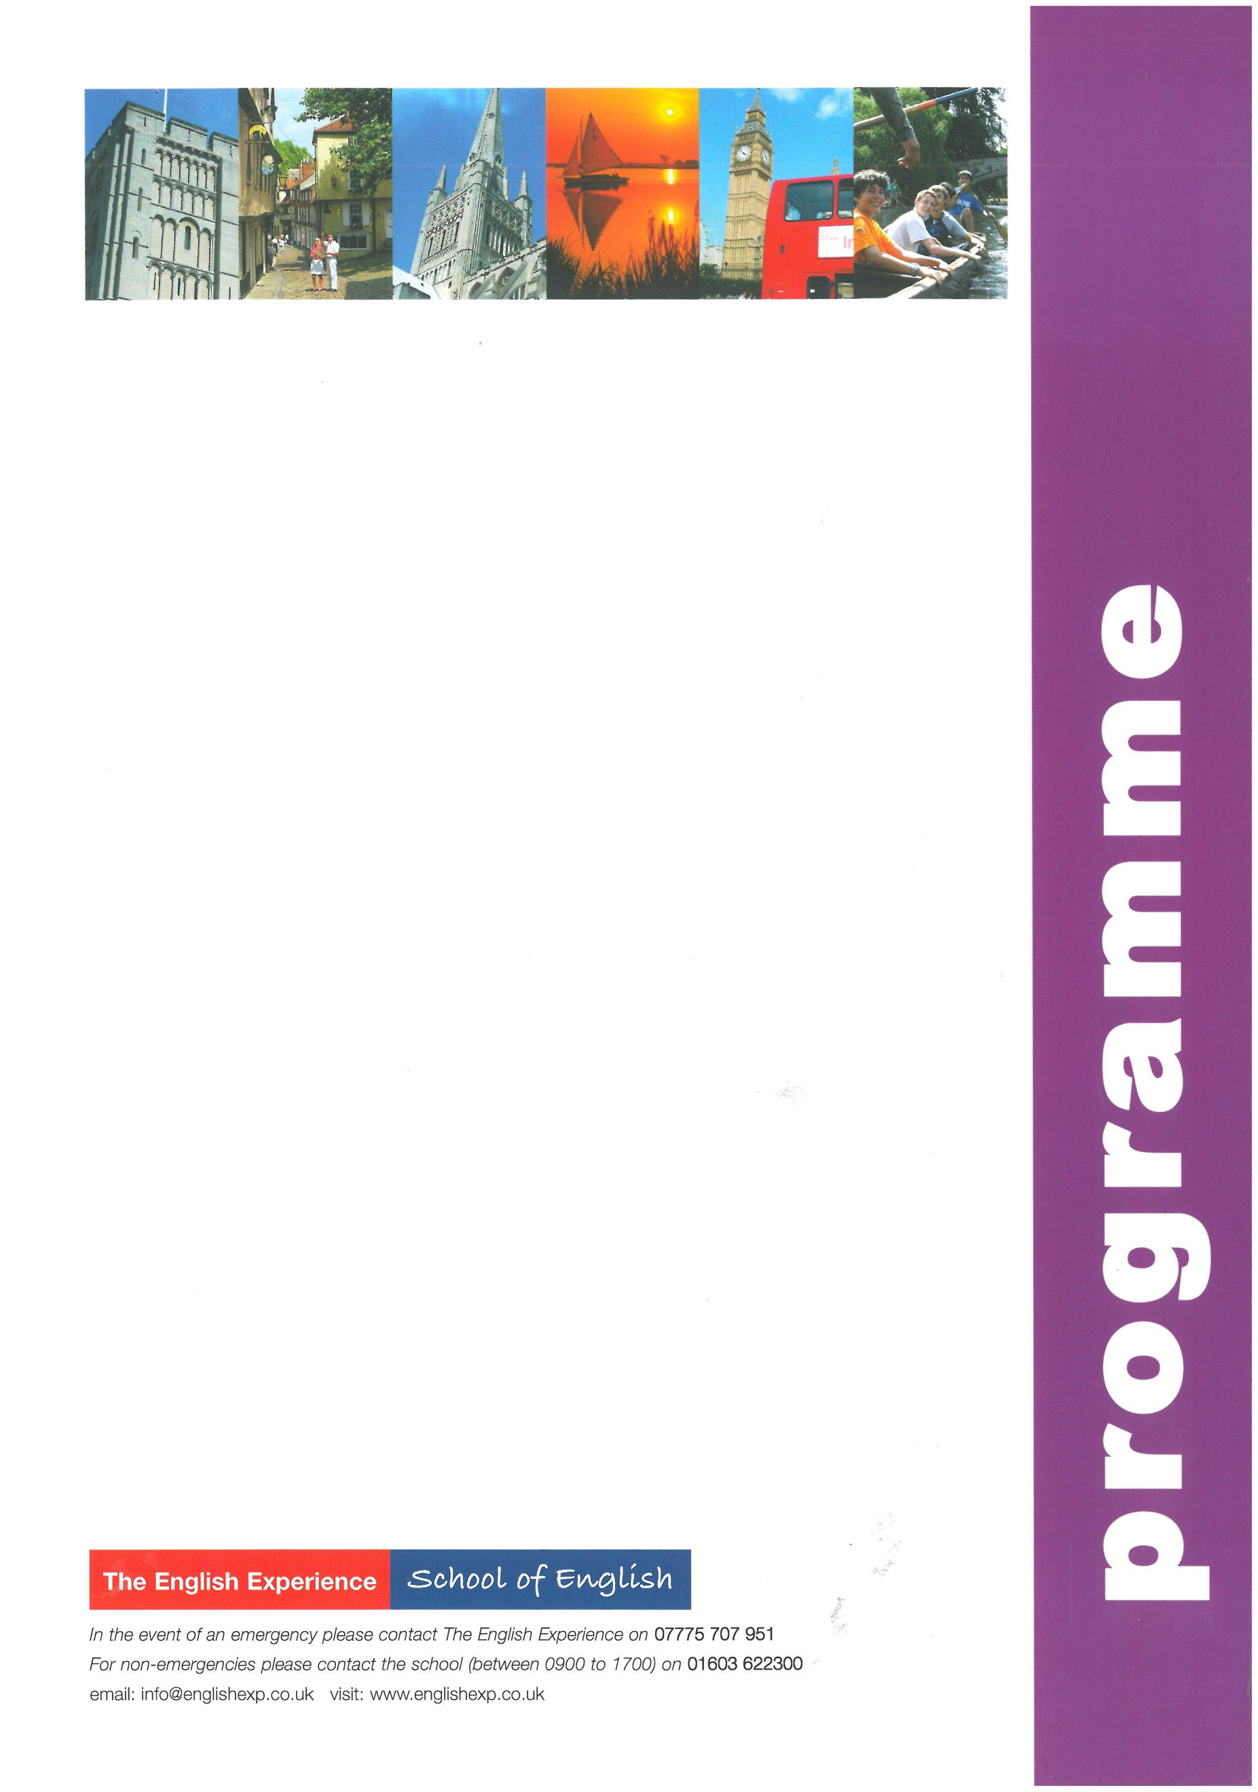
Sample Programme - Cambridge Exam Preparation 2 Weeks
(KET, PET, FCE, CAE)
GROUP:
LEADERS:
CURFEW:
Sun | Times to be advised | Students arrive in Norwich and meet Homestay Hosts
Mon | 0900 - 1230  1400 - 1700 | Welcome Talk and Cambridge Exam Preparation Lessons  Orientation Tour of Norwich - how to find the post office, bank, library, bus stops and meeting points
Tues | 0900 - 1230  1430 - 1700 | Cambridge Exam Preparation Lessons  Cambridge Exam Workshop
Wed | 0900 - 1230  1330 - 1800 | Cambridge Exam Preparation Lessons  Half-Day Excursion to the seaside resort of Great Yarmouth to include a heritage walk and a visit to the ‘Time and Tide’ Museum
Thurs | 0900 - 1230  1430 - 1700 | Cambridge Exam Preparation Lessons  Cambridge Exam Workshop
Fri | 0900 - 1230  1400 - 1700 | Cambridge Exam Preparation Lessons  A visit to Norwich Cathedral and Riverside Walk
Sat | 0900 - 1800 | Full-Day Excursion to Cambridge to include a walking tour of the main colleges and a visit to Pembroke College
Sun |  | Free Day with Homestay Hosts
Mon | 0900 - 1230  1400 - 1700 | Cambridge Exam Preparation Lessons  A visit to Norwich Castle Museum and discover its past as a palace and prison
Tues | 0900 - 1230  1430 - 1700 | Cambridge Exam Preparation Lessons  Cambridge Exam Workshop
Weds | 0900 - 1230  1330 - 1800 | Cambridge Exam Preparation Lessons  Half-Day Excursion to Blakeney Point on the north Norfolk coast - take a boat trip to see the seals
Thurs | 0900 - 1230  1430 - 1700 | Cambridge Exam Preparation Lessons  Cambridge Exam Workshop
Fri | 0900 - 1230  1400 - 1700 | Cambridge Exam Preparation Lessons and Presentation of Reports  10-Pin Bowling at Hollywood Bowl, Riverside
Sat | 0720 - 2000 | Full-day Excursion to London to include a walking tour past the main sights: Houses of Parliament, Whitehall, Trafalgar Square, Westminster Abbey, Buckingham Palace. Lunch in St James’ Park and free time for shopping or to visit a museum or art gallery
Sun | Times to be advised | Students depart Norwich for return journey home

