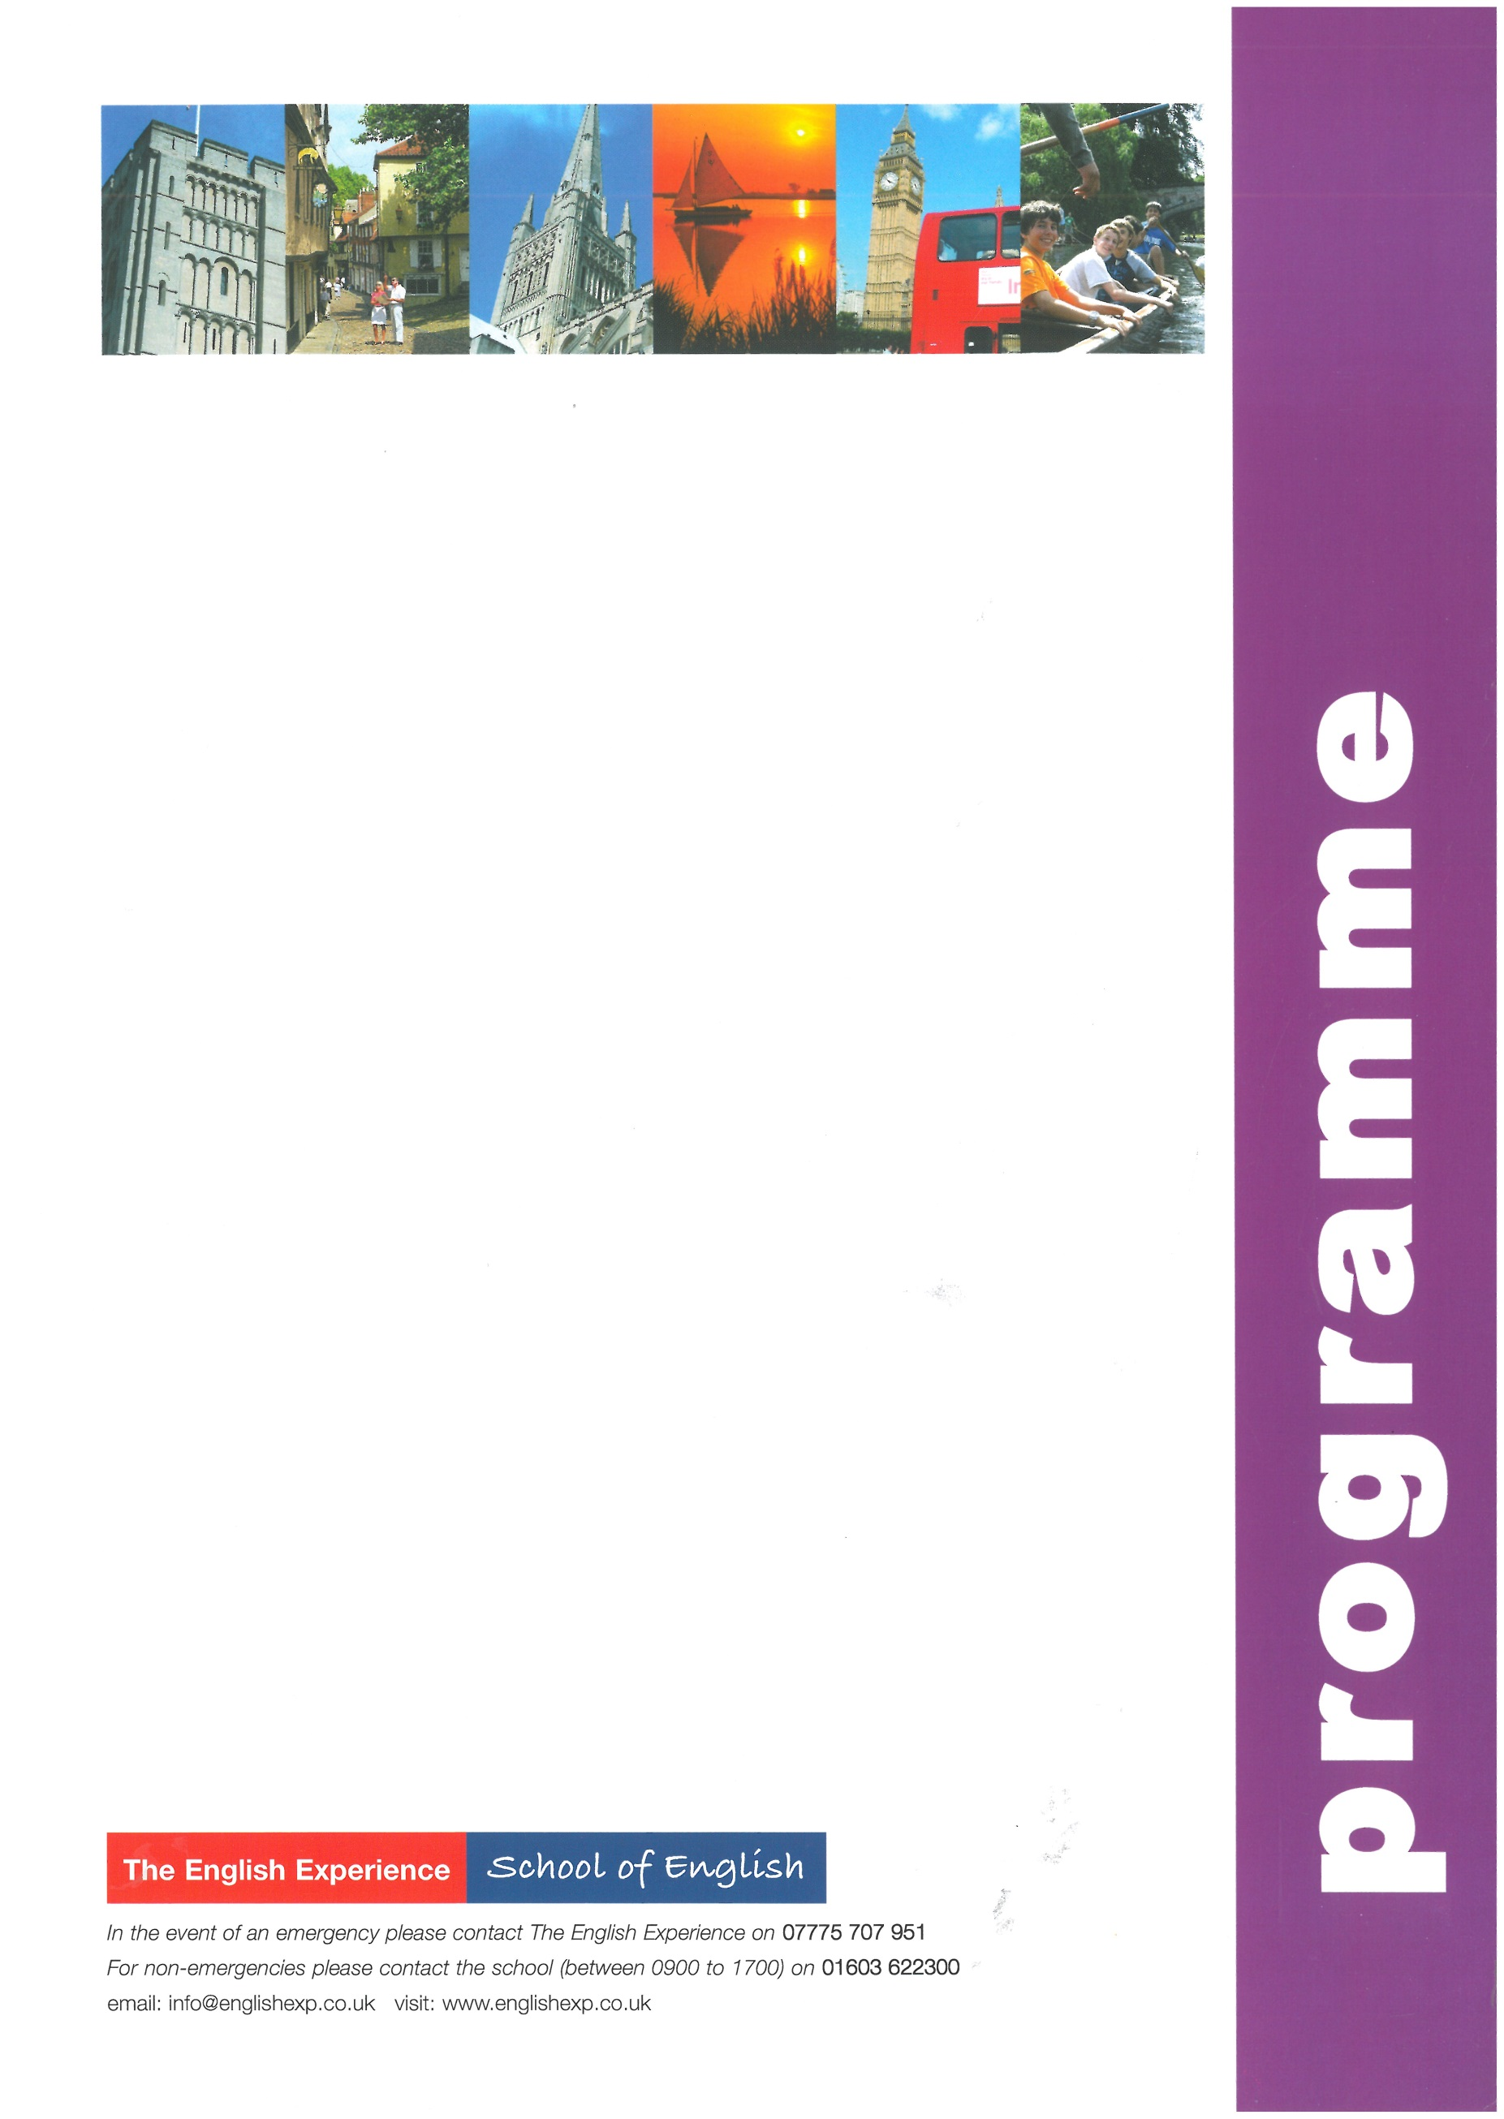
Sample Programme - Summer Study Holiday 1 Week
GROUP:
LEADERS:
CURFEW:
WEEK ONE
Sun | Times to be advised | Students arrive in Norwich and meet Homestay Hosts
Mon | 0900 -1230  1400 -1700 | Welcome Talk and English Lessons  Orientation Tour of Norwich. How to find the bank, post office, shops and meeting points
Tues | 0900 - 1230  1400 - 1700  1930 - 2200 | English Lessons  A visit to Norwich Cathedral and a Riverside Walk  Student Disco at The Talk, Oak Street
Wed | 0900 - 1230  1330 - 1800 | English Lessons  Half-Day Excursion to the seaside town of Great Yarmouth to include a heritage trail and a visit to the Time and Tide Museum
Thurs | 0900 -1230  1400 -1700 | English Lessons  Outdoor Activities at Eaton Vale Activity Centre - choices include as Archery, Crate-Staking, Canoeing and Raft-Building
Fri | 0900 - 1230  1400 - 1700 | English Lessons & Presentation of Certificates  An entertaining singing workshop at ‘Create’ Studios, Norwich
Sat | 0900 - 1800 | Full-Day Excursion to Cambridge to include a walking tour past the main college and an optional visit to one of the colleges
Sun | Times to be advised | Students depart Norwich for return journey home

