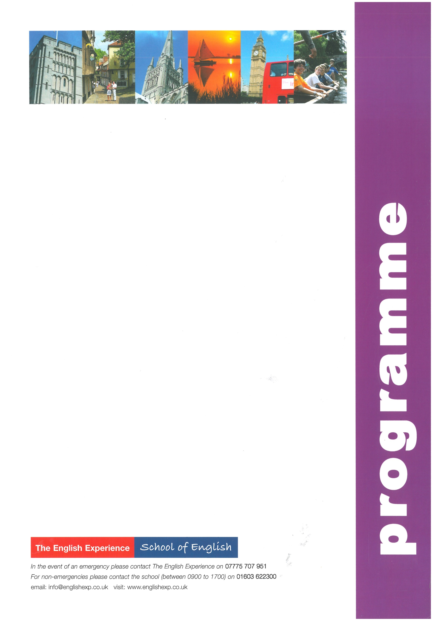
Sample Programme - Short Course 13 Nights
GROUP:
LEADERS:
CURFEW:

WEEK ONE
Sun | Times to be advised | Students arrive in Norwich and meet Homestay Hosts
Mon | 0900 - 1230  1400 - 1700 | Welcome Talk, Placement Tests and English Lessons  Orientation of Norwich. How to find the bank, post office, shops and excursion departure points
Tues | 0900 - 1230  1400 - 1700  1930 - 2200 | English Lessons  Sports in the Park  Student Disco at The Talk, Oak Street *Numbers Dependent*
Weds | 0900 - 1230  1400 - 1700 | English Lessons  City Search - Navigate your way around Norwich and the winning team receives a prize
Thurs | 0900 - 1230  1400 - 1700 | English Lessons  A visit to Norwich Castle to discover its past as a former royal palace and prison
Fri | 0900 - 1230 | English Lessons  Free afternoon for shopping and exploring more of Norwich
Sat | 0720 - 2000 | Full-Day Excursion to London to include a walking tour past the sights: Houses of Parliament, Whitehall, Trafalgar Square, Westminster Abbey, Buckingham Palace. Lunch in St James’s Park. Free time for shopping or to visit a museum or art gallery.
WEEK TWO
Sun |  | Free day with Homestay Hosts
Mon | 0900 - 1230  1400 - 1700 | English Lessons  10-Pin Bowling at Hollywood Bowl, Riverside
Tues | 0900 - 1230  1400 - 1700  1930 - 2200 | English Lessons  A visit to the Sainsbury Centre for Visual Art at the University of East Anglia  Student Disco at The Talk, Oak Street *Numbers Dependent*
Weds | 0900 - 1230  1400 - 1700 | English Lessons  A visit to Norwich Cathedral and Riverside Walk
Thurs | 0900 - 1230  1400 - 1700 | English Lessons  A trip to the Cinema to see one of the latest releases
Fri | 0900 - 1230 | English Lessons and presentation of reports  Free afternoon for shopping and exploring more of Norwich
Sat | Times to be advised | Students depart Norwich for return journey home

