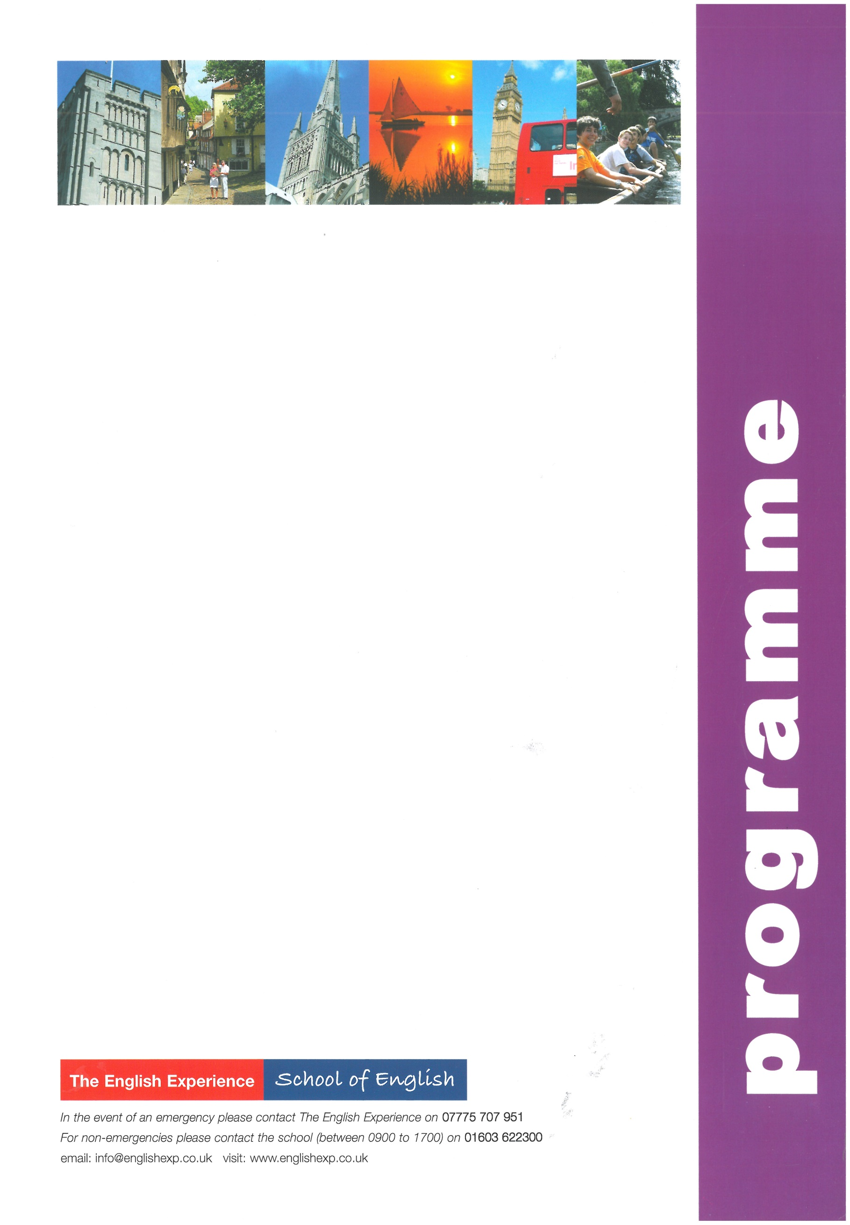
Sample Programme - IELTS Exam 1 Week
GROUP:
LEADERS:
CURFEW:

Sun | Times to be advised | Students arrive in Norwich and meet Homestay Hosts
Mon | 0900 - 1230  1400 - 1700 | Welcome Talk and IELTS Exam Preparation Lessons  Orientation Tour of Norwich - how to find the post office, bank, library, bus stops and meeting points
Tues | 0900 - 1230  1430 - 1700 | IELTS Exam Preparation Lessons  IELTS Exam Workshop
Wed | 0900 - 1230  1330 - 1800 | IELTS Exam Preparation Lessons  Half-Day Excursion to Blickling Hall in north Norfolk - visit a typical English country house and its gardens
Thurs | 0900 - 1230  1430 - 1700 | IELTS Exam Preparation Lessons  IELTS Exam Workshop
Fri | 0900 - 1230  1400 - 1700 | IELTS Exam Preparation Lessons and Presentation of Reports  IELTS Exam
Sat | 0720 - 2000 | Full-Day Excursion to London to include a walking tour past the main sights; Houses of Parliament, Whitehall, Trafalgar Square, Westminster Abbey, Buckingham Palace and Covent Garden with lunch in St James’s Park. Free time to visit an art gallery or museum
Sun | Times to be advised | Students depart Norwich for return journey home

