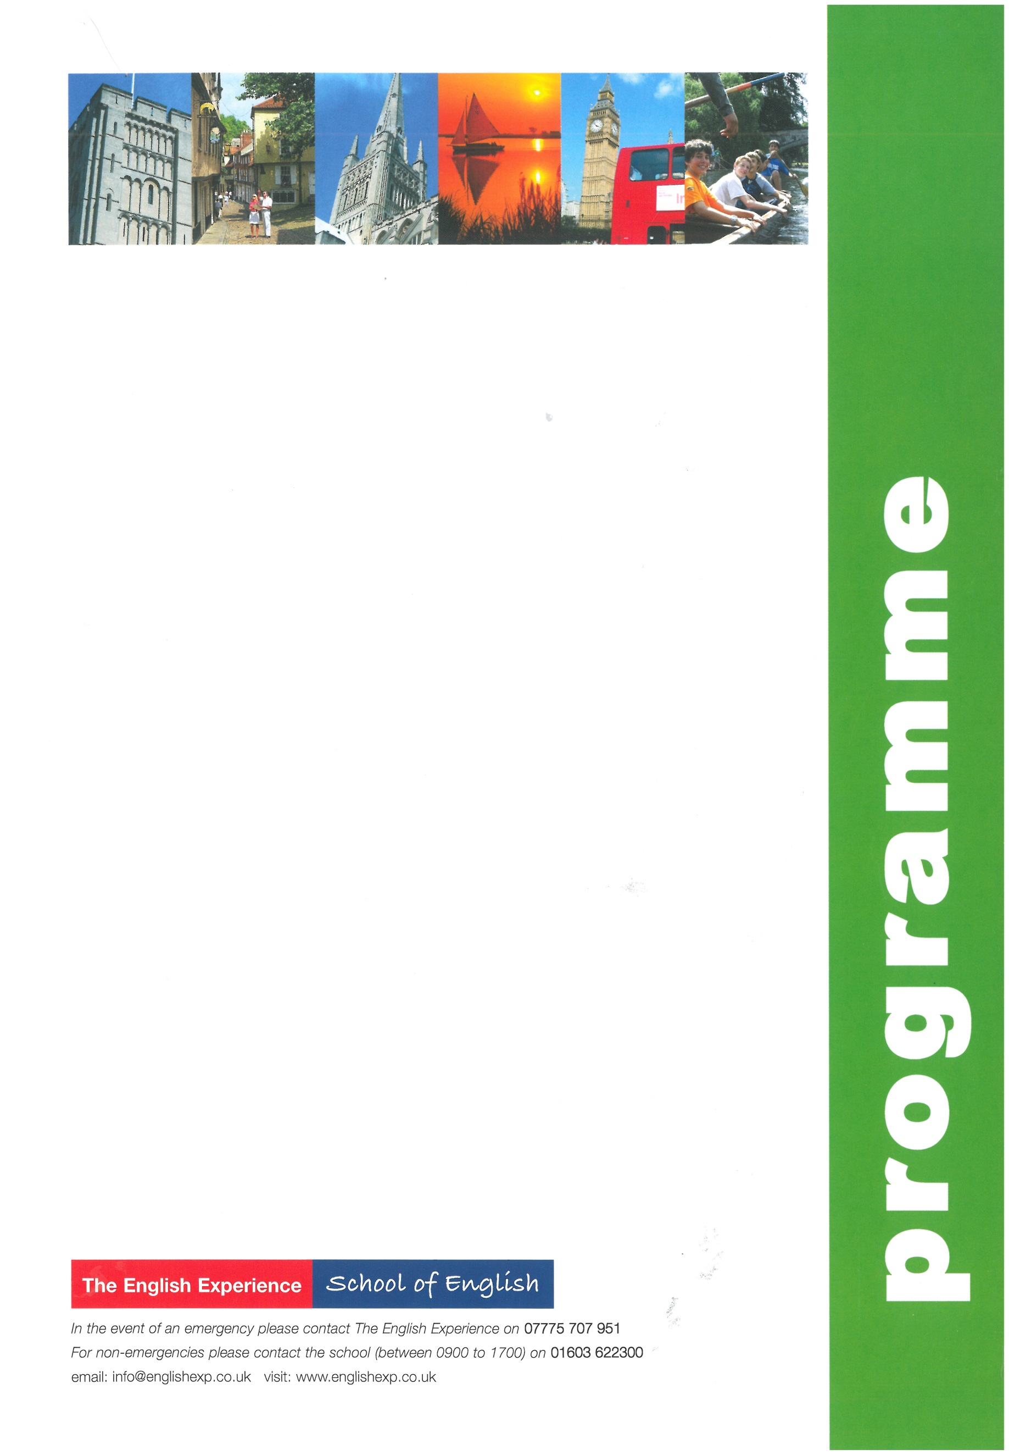
Sample Programme - Trinity GESE Exam 2 Weeks
GROUP:
LEADERS:
CURFEW:

Sun | Times to be advised | Students arrive in Norwich and meet Homestay Hosts
Mon | 0900 - 1230  1400 - 1700 | Welcome Talk and English Lessons  Orientation Tour of Norwich - how to find the post office, bank, library, bus stops and meeting points
Tues | 0900 - 1230  1430 - 1700 | GESE Exam Preparation Lessons  GESE Exam Workshop
Wed | 0900 - 1230  1330 - 1800 | GESE Exam Preparation Lessons  Half-Day Excursion to Blakeney Point on the north Norfolk coast to take a boat trip to see the seals
Thurs | 0900 - 1230  1430 - 1700 | GESE Exam Preparation Lessons  GESE Exam Workshop
Fri | 0900 - 1230  1400 - 1700 | GESE Exam Preparation Lessons  A visit to Norwich Cathedral and a Riverside Walk
Sat | 0900 - 1800 | Full-day Excursion to Cambridge to include a walking tour past the main colleges and a visit to Pembroke College
Sun |  | Free day with Homestay Hosts
Mon | 0900 - 1230  1400 - 1700 | GESE Exam Preparation Lessons  A visit to Norwich Castle Museum to discover its past as a royal palace and prison
Tues | 0900 - 1230  1400 - 1700 | GESE Exam Preparation Lessons  GESE Exam Workshop
Weds | 0900 - 1230  1330 - 1800 | GESE Exam Preparation Lessons  Half-Day Excursion to the seaside resort of Great Yarmouth to include a heritage trail and a visit to the Time and Tide Museum
Thurs | 0900 - 1230  1400 - 1700 | GESE Exam Preparation Lessons  GESE Exam Workshop
Fri | 0900 - 1230  1400 - 1700 | GESE Exam Preparation Lessons and Presentation of reports  GESE Exam
Sat | 0720 - 2000 | Full-Day Excursion to London to include a walking tour past the main sights; Houses of Parliament, Whitehall, Trafalgar Square, Westminster Abbey, Buckingham Palace and Covent Garden with lunch in St James’s Park. Free time to visit an art gallery or museum
Sun | Times to be advised | Students depart Norwich for return journey home

